

January 17, 2019

General Description

Description of the PowerBI app in Odoo.

Odoo - POWERbi

Odoo - PowerBI

Table of Contents

Overview 2

Administering the PowerBI app 2

User Account Settings 2

Configuration 3

Issue Handling 3

# Overview

The PowerBI app adds an icon on the main menu page that opens the server specified in the Settings area.

# Administering the PowerBI app

Once installed, the PowerBI app is configured via the Settings app and is enabled via individual account permissions.

## User Account Settings

To give access permissions to a User, open the users via the **Settings** app:

1. Open **Settings**/**Users**

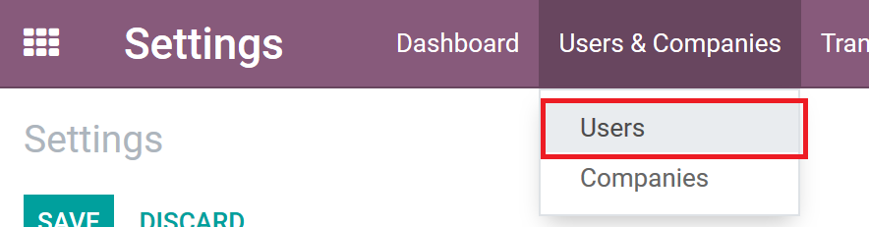

1. Open the **User** in edit mode
2. Find the PowerBI permission area and give the proper permissions via the drop down.
   1. **Blank**: No access to the app and the user will not see the icon on their menu.
   2. **User**: Gives access to the app on the Odoo main menu.
   3. **Administrator**: Gives the user access to change the URL in the Odoo Settings area

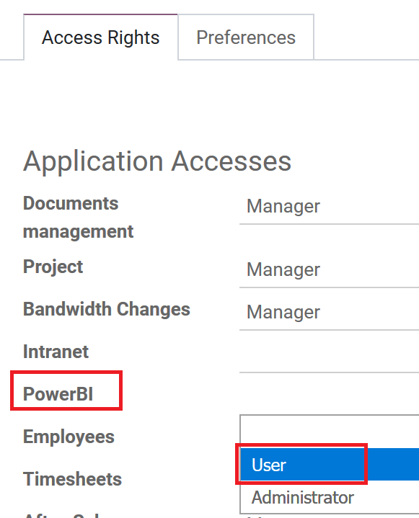

1. Click **Save**
2. The User may need to refresh their browser but should now see the app icon on their main menu.

## Configuration

You can change the URL used for the PowerBI app in the Odoo Settings area.

1. Make sure you have Administrator permissions to the PowerBI App
2. Open the **Settings** app
3. Go to **General Settings**
4. Select **PowerBI** on the left side
5. Enter the **PowerBI Server URL**

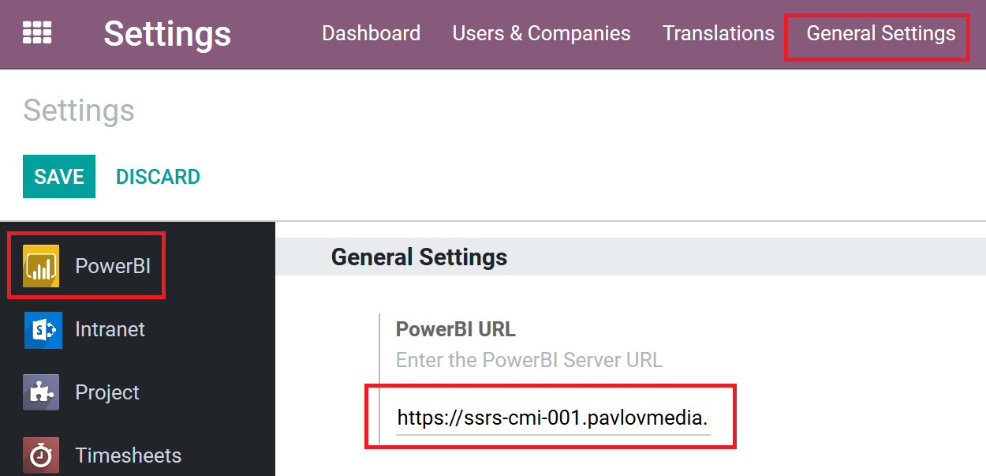

1. Click **Save**
2. Now anyone who clicks the icon on their main menu will open the URL set in settings.

# Issue Handling

For issues that may arise submit a MIS ticket for the System Integration team to investigate the issue; below is the link to the ticketing system.

<https://cwise.shout.net/v4_6_release/services/system_io/customerportal/portal.html?company=sgt&locale=en#LoginPagePlace:LOGOUT>